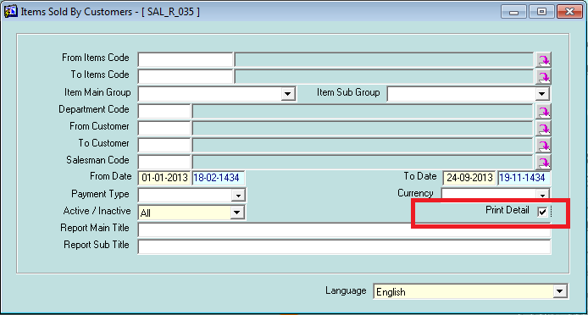

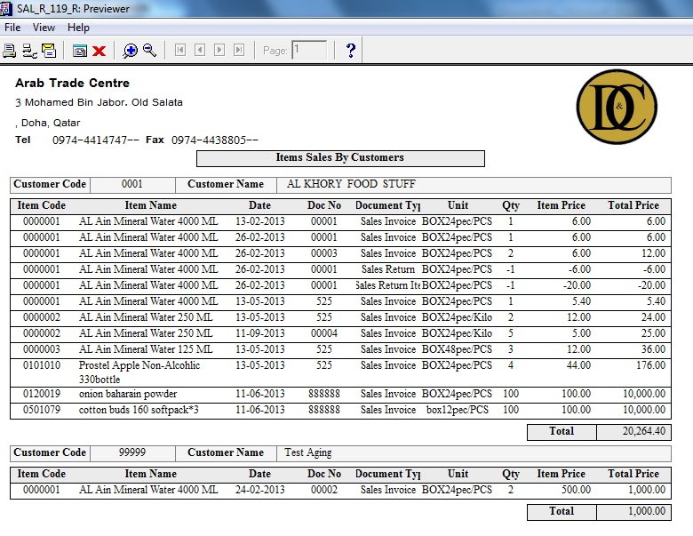

New parameter is added GL Statement of account is sub systems

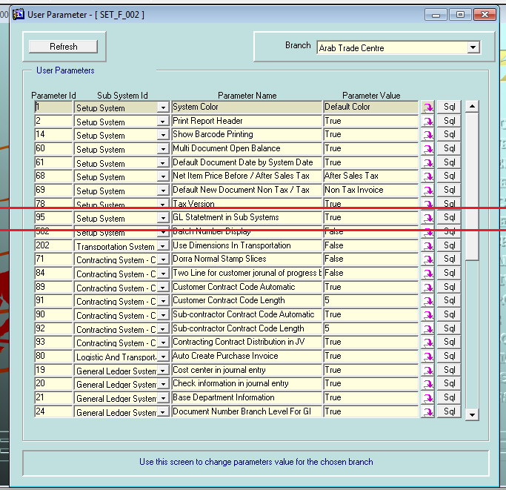

When u make this parameter true

Customer open balance disappear in sales system

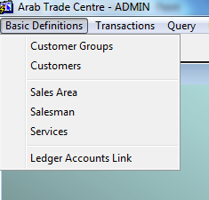

Customer statement of account in sales replace by GL as shown

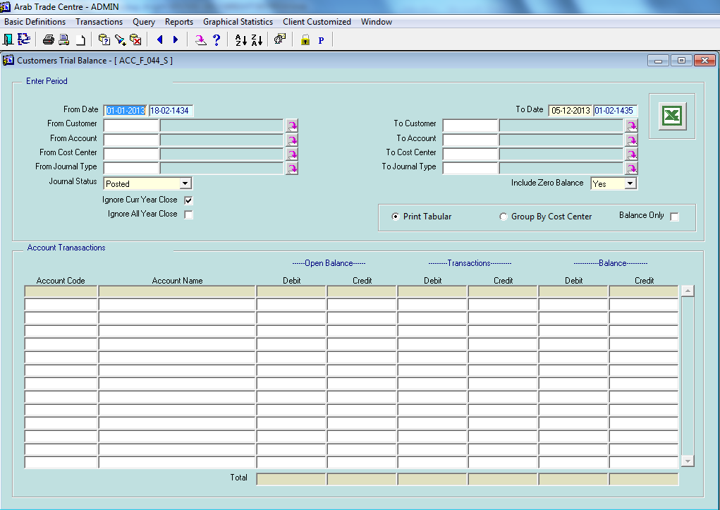

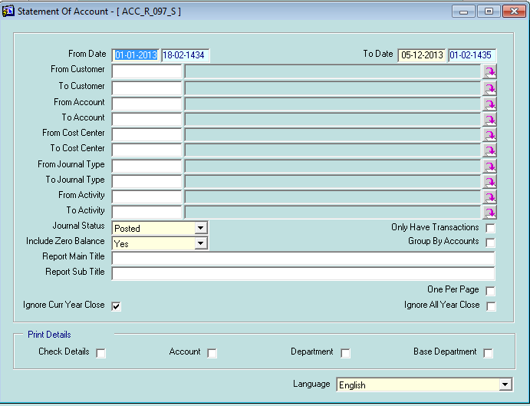

1. Enhance the customer and supplier credit aging prints to retrieve data more fast with high performance also add some info. For customer and supplier as following: 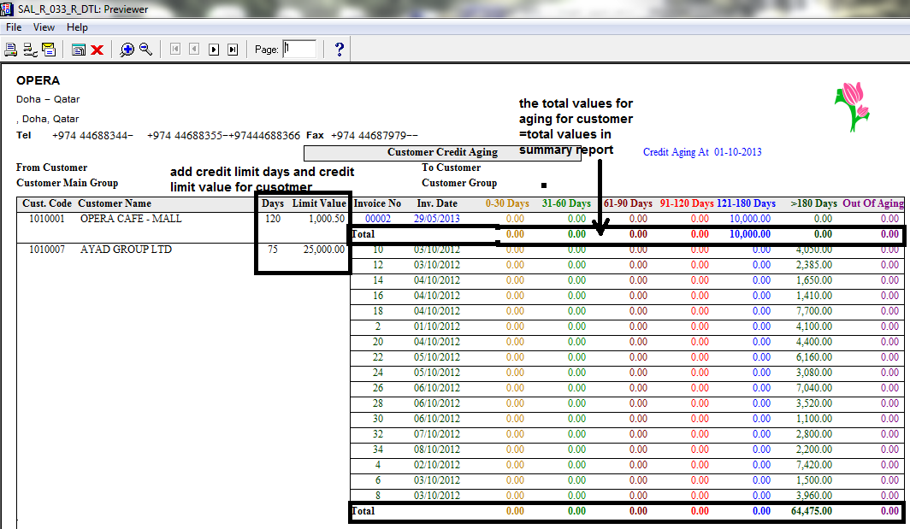

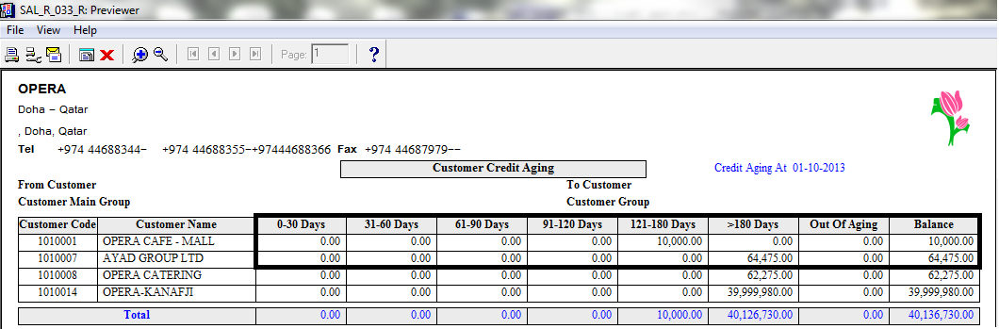

Supplier credit aging look like customer aging typically

2-Option to enter Customer wise price List as shown in next screen shot:

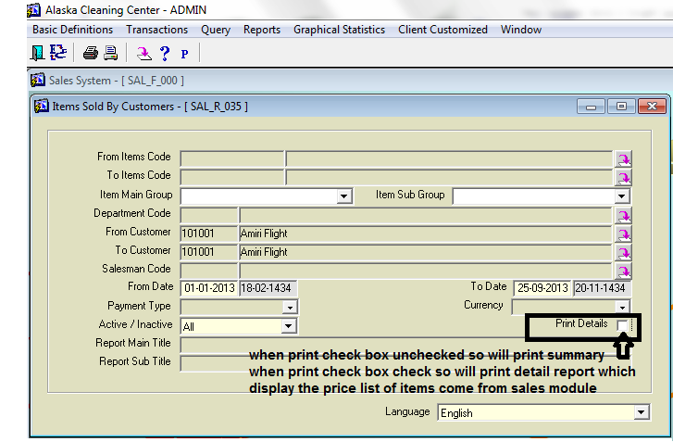

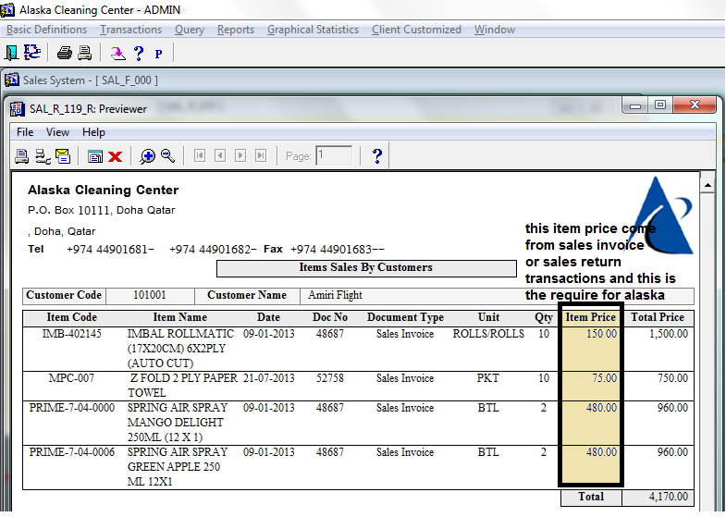

3-Adding totals of quantity in delivery order notes in details with some enhance for layout as following:

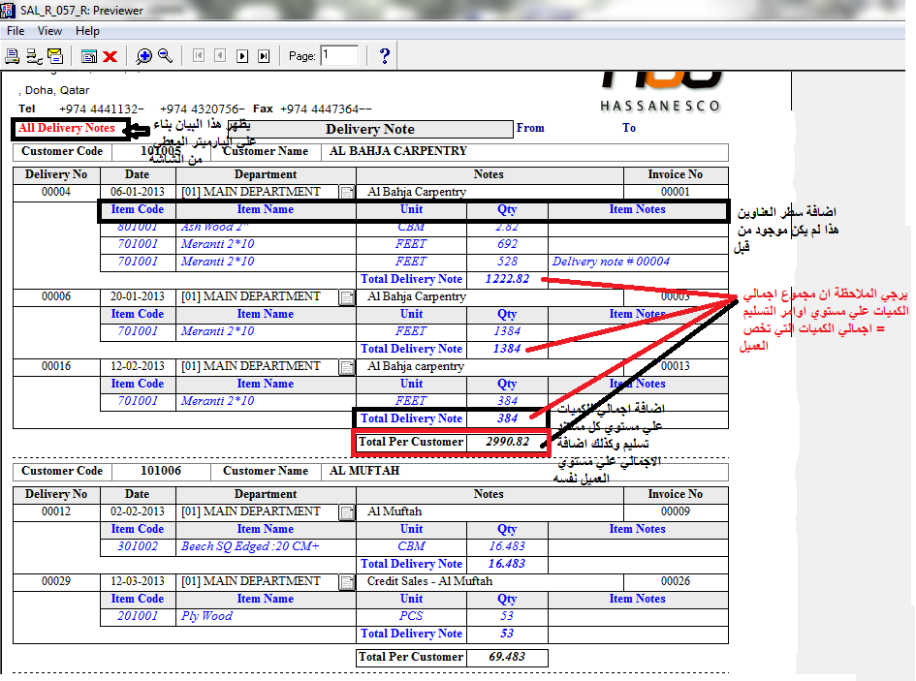

4-Add some new features in Sales item quantity screen by display selling price for specific store item coming from each sales invoice or sales return document which this item found in also do better performance for query process than before also add this new feature in process of export data from bright application to excel sheet.

The following screen shot will explain what done in details: date from 27 to 30-09-2013

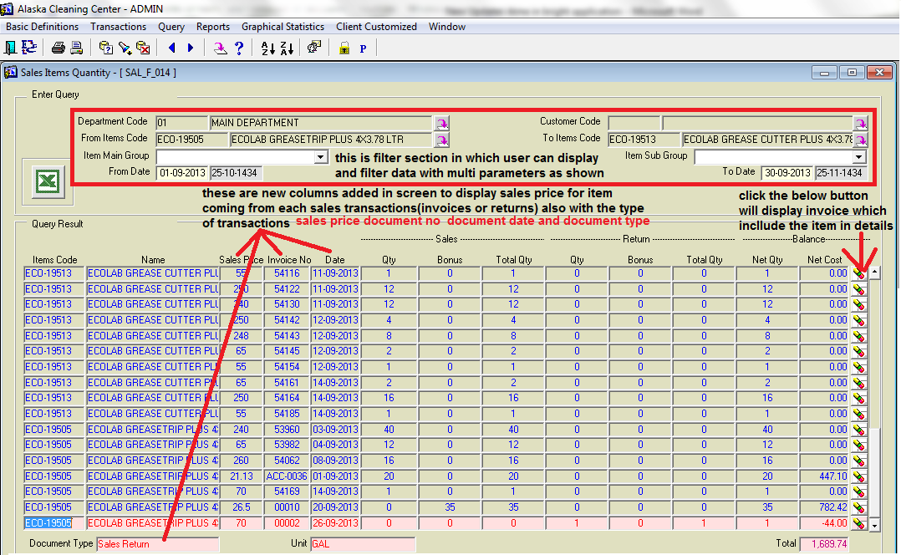

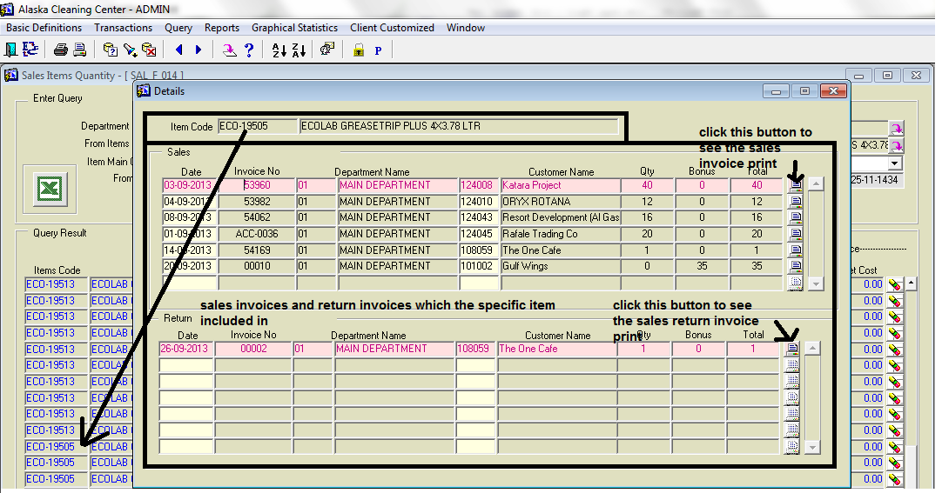

Also report of the above screens give the same results as following:

